CHAROTAR UNIVERSITY OF SCIENCE AND TECHNOLOGY
FACULTY OF TECHNOLOGY AND ENGINEERING (FTE)
DEVANG PATEL INSTITUTE OF ADVANCE TECHNOLOGY AND RESEARCH
IT355: SOFTWARE ENGINEERING
QUESTION BANK : UNIT 6,7
- Explain the reasons behind the following assertion “Adding more manpower to a late project makes it later”.
- What are the major goals of SQA? List the SQA tasks that need to be performed by SQA group. What are the effective methods to ensure the success of SQA?
- When are verification and validation performed during the software lifecycle? What do you mean by TQM and explain any four key elements of TQM.
- State the essential features of ISO 9000 certification. Write down the merits and demerits of ISO 9001:2000 certification.
- Explain WBS (work-breakdown structure) with an example.
- What is FTR? List out the objectives of it? Describe the design walk-through and critical design review.
- Justify that “Software Quality Assurance is an umbrella activity”.
- What practices should software engineers follow to enhance the quality of the software produced by their team?
- What is the significance and importance of CMM certification for any software organization? Is it possible for an organization to achieve higher level of CMM without achieving a lower one? Justify.
- What is software testing and why is it required? Explain the general guidelines for performing software testing? Differentiate between Black-Box testing and Structural (White-Box) Testing. What are the types of White-Box testing? Explain the step by step procedure to calculate the cyclomatic complexity.
- Which are the activities performed by Quality Assurance (QA) Department? Briefly explain.
- What do you mean by TQM? Explain the key elements of TQM.
- What is FTR? List out the objectives of it? Describe design walk through and code walkthrough. Explain critical design review.
- Is it possible to test the software exhaustively? Can anyone guarantee that the product delivered is 100% error free even after thorough testing? Justify your answer.
- What is the need of quality certification(s)? Describe the process and requirements of ISO 900X certification. What can you make out as a newly approached client, if the approaching software company is currently at CMM Level 4 and has an ISO 9001 certification?
- Is it ethical for a software engineer to agree to deliver a software system with known faults to a customer? Does it make any difference if the customer is told of the existence of these faults in advance? Would it be reasonable to make claims about the reliability of the software in such circumstances?
- What according to you is a good quality software product? How can such products be developed?
- What do you mean by LIP, CFG and McCabe’s cyclometric metric? How to find each one of them? How are they related? Explain by taking a suitable example.
- Do you agree with the following statement “The reliability of a software product increases almost linearly, each time a defect gets detected and fixed”? Justify your answer.
- Distinguish between error and failure in terms of Software Defect? Which of the two is detected by Software testing? Justify your answer. Is it possible to test the software exhaustively? Justify your answer. Can anyone guarantee that the product delivered is 100% error free even after thorough testing?
- Give examples of defects that you would be able to detect during code inspection and code walk through. Why is it advantageous to detect as many errors as possible during code review than during testing?
- Suppose an organization mentions in its job advertisement that it has been assessed at level 3 of SEI CMM, what can you infer about the current quality practices at the organization? What does this organization have to do to reach SEI CMM level 4?
- 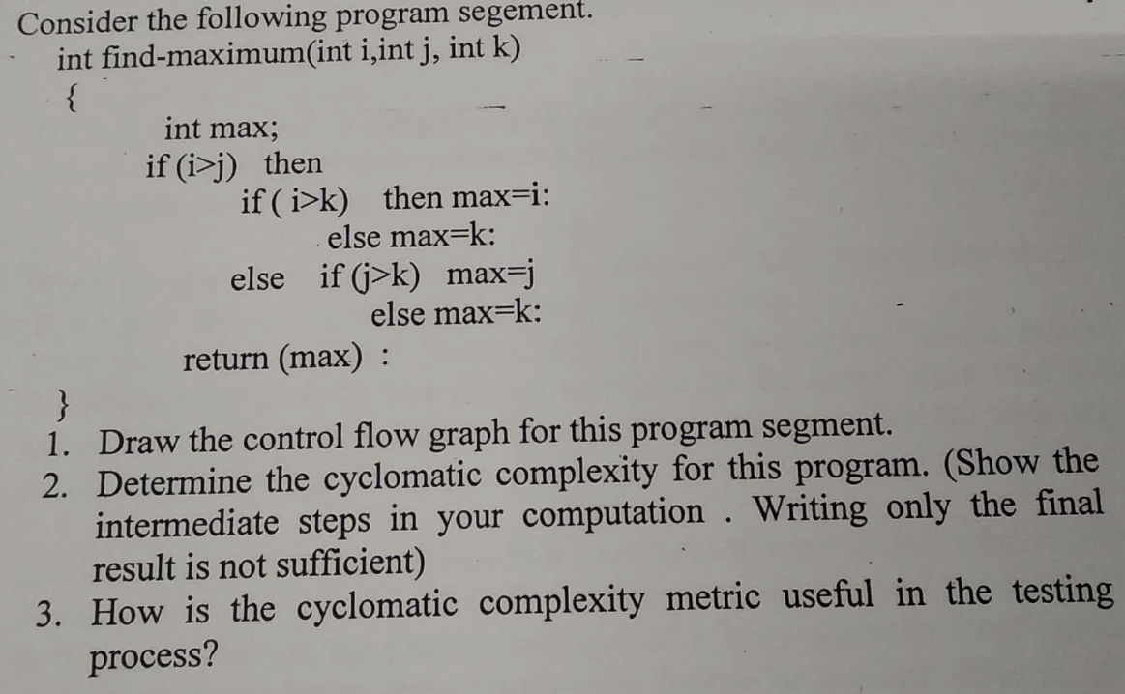
- Software computes the cube root of an input integer, which can assume values from 1 to 1000. Find the test cases for this program from considerations of;
  - Equivalence class partitioning
  - Boundary value analysis
- What are the factors of software quality?
- Draw a control flow graph and find Cyclomatic Complexity for given code.
insertion_procedure (int a[], int p [], int N)
{
(1) int i,j,k;
(2) for ((2a)i=0; (2b)i<=N; (2c)i++)
(3) p[i] = i;
(4) for ((4a)i=2; (4b)i<=N; (4c)i++)
{
(5) k=p[i];j=1;
(6) while (a[p[j-1]] > a[k]) {
(7) p[j] = p[j-1];
(8) j--
}
(9) p[j] = k;
}}

- Explain in brief the various elements of Software Project Management and Planning document. Explain the various roles of Software Project Manager.
- What is the use of CMM? Explain the capability maturity model.
- What are the basic principles of software testing? Explain the types of System testing?
- Which are the various umbrella activities of SQA? Explain the merits and demerits of ISO 9001.
- What are the various guidelines of Formal Technical Review (FTR)?
- Why is it necessary to go for integration testing? Explain the various approaches of integration testing.
- Name two software quality models? Explain the SEI capability maturity model.
- Define Quality assurance. What are the five major areas of SQA?
- Differentiate between Black-Box and White-Box testing. Briefly describe any one method.
- Effective software project management focuses on four spectrums. Enlist them in order and explain them. What are the characteristics of an effective project manager?
- Explain why program inspections are an effective technique for discovering errors in a program.
- Briefly highlight the difference between “code walk-through” and “code inspection”. Compare the relative merits and demerits of the same.
- Why is it advantageous to detect errors during code and design reviews rather than leaving them to detect at the time of testing?
- What do you mean by software testing? What do you mean by debugging? Enlist and explain the various testing and debugging techniques in brief.
- Write note on: Alpha Testing, Beta Testing and Acceptance Testing.
- How is cyclomatic complexity useful in program test? What is sequence of testing? What is testability?
- Write a note on: Key process areas of Capability Maturity Model (CMM).
- Define software testing. Explain various levels of testing.
- Write a note on “The software team”. As a project manager, identify the traits that you would look for in a software engineering while trying to select personnel for your team.
- What is the difference between Audit and Formal Technical Review (FTR)? Can their function be folded in to the review? What are the pros and cons?
- Is it true that “High quality software process should lead to high quality software products”? Justify.
- Explain why program inspections are an effective technique for discovering errors in a program. What purpose do “walkthrough” serve? How do we accomplish this?
- An organization is assessed at level 4 of SEI CMM, what can be inferred about the current quality practices of the organization? What does the organization have to do to reach SEI CMM Level 5?

